Wezzle by Couchware Inc.  - Genre: Casual/Puzzle.  - Number of Players: 1 or 2 (via Bluetooth).  - Platform: Mobile.  - Ship Date: Second-Half 2008.  - Developer: Couchware Inc.  - Publisher: TBD. | 

Wezzle is an action puzzle game in which players must eliminate tiles from the board faster than they are added. Players must race against the clock to clear lines, explode bombs, and set off exciting chain reactions to score as many points as they can before the board fills up. Each level is increasingly challenging, requiring faster moves and more points, pushing the player to clear lines more and more quickly.

Features  - Addictive fast-paced action.  - Innovative subtractive game-play.  - Save your scores and progress.  - Challenge your friends in multiplayer mode via Bluetooth.  - Compare your scores with others online.  - State-of-the-art animations, sound effects and music.  - Complete challenges to unlock new art and game-play modes. | 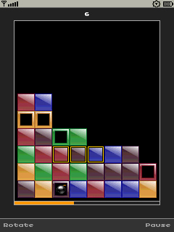

Copyright © 2008 Couchware Inc. All rights reserved.

